Bibliography  Mad Libs:  http://atthechalkface.com/tag/mad-lib/  Rubric  http://rubistar.4teachers.org/index.php  Sample Scripts  http://bigeducationape.blogspot.com/2013/04/big-education-ape-morning-wink-4-17-13.html  Animation Vocabulary  http://quizlet.com/19048837/animation-vocabulary-flash-cards/ |  |  | Intro to Animation  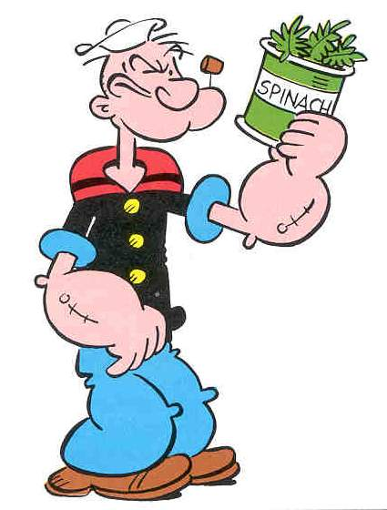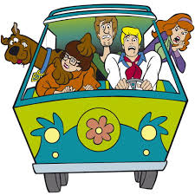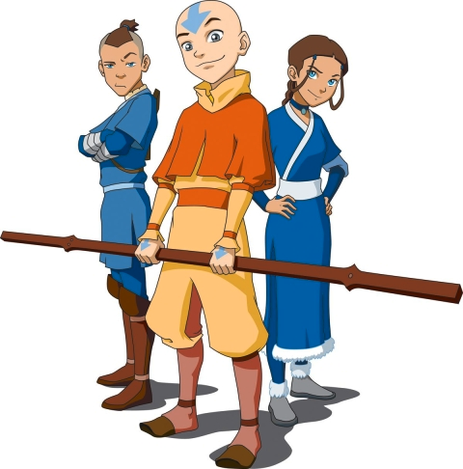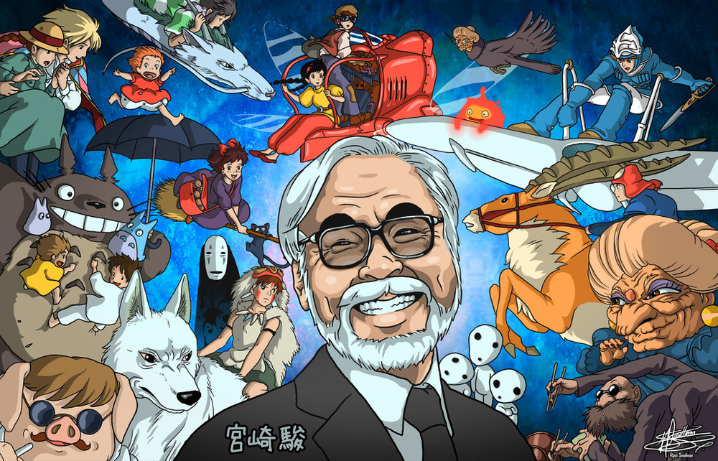

Brainstorm Your Idea!  Your Team:  Writer - _____________________________________  Illustrator - _____________________________________  Animator - _____________________________________  Musician - _____________________________________  Computer Genius - _____________________________________ |  |  | Animation tips and Vocabulary  - Keep your cool  - __________ – Going over with pen and cleaning up pencil drawings.  - _______________ – Illuminate your cartoon! Color by hand or with the computer.  - _________________– A great tool to add emotion to your characters.  - _________________________ – Explore your environment to find things that make interesting sounds.  - ________________ – Putting all of your components together on the computer.  - ___________________ – Gather all the people you can find for your first showing.
2 |  |  | 7

Ready, Set…Animate!  - First record any voices.  - Scan in your storyboard and establish the flow and timing by creating an ____________________________.  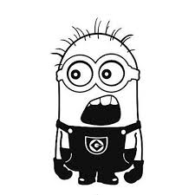  - _________________ are drawn in order to define pivotal points of motion.  - In-betweens are called _________________ when an animating computer program generates them. |  |  | Character Vectors  Create a simple character based on a circle shape with different actions and expressions.  Jump  Walking  Silly  Angry  Sad  Happy
6 |  |  | 7 | 3

Create a Script…  Instructions: In each blank space, ask a partner to give you a word that that matches the description below. Example: Place= Long Beach; Adjective=Weird  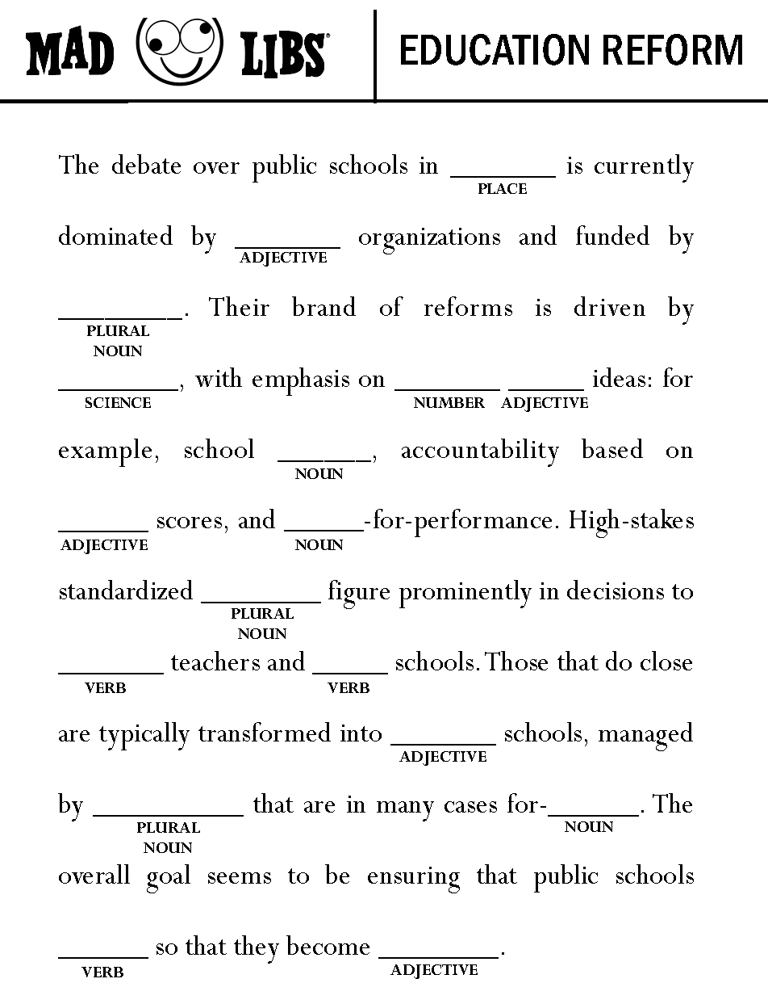 |  |  | Build a Story Board.
4 |  |  | 5

